WE SALUTE OUR LOCAL FIRE DEPARTMENTS!
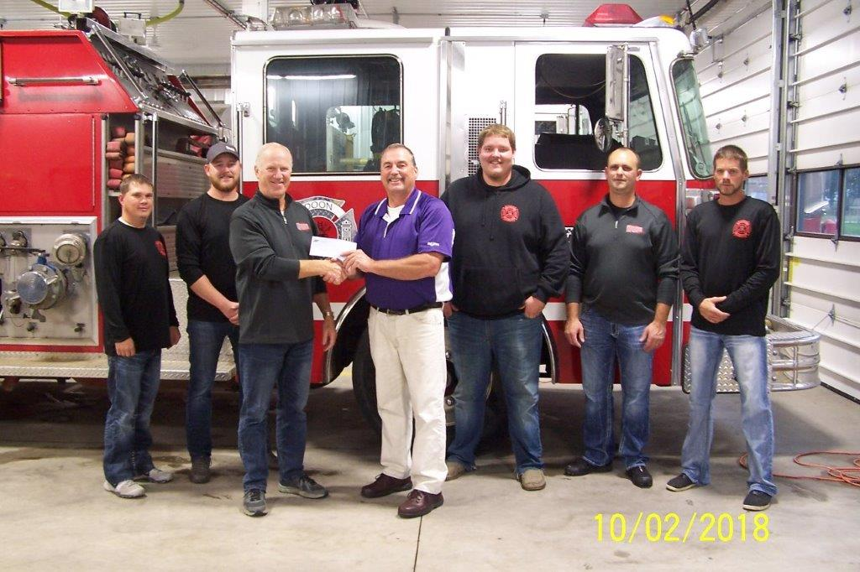
FARMERS MUTUAL INSURANCE FIRE DEPARTMENT GRANT PROGRAM 2026
In honor of Fire Prevention Week Farmers Mutual Insurance of Hull is providing a $1,500 grant to the ____ fire department. This grant was made possible by a nomination from the _______ agency. Pictured above presenting the $1,500 check is ______. Accepting the check is ______ from the ____ fire department. As a local insurance company, we recognize the importance of the volunteer fire departments in our area, and want to support them. Thank you to the ____ agency for nominating the ____fire department for this grant! 